ITERATION METHOD - EXERCISE PROBLEMS
- Find a root of the equation x³ – 4x + 1 = 0 by using iteration method.
- Find a root of the equation x³ + x² - 1 = 0 by using iteration method.
- Solve for x from cos x – xe^{x} = 0 by iteration method.
- Solve x³ = 2x + 5 for the positive root by iteration method.
- Find a positive root of 3x - 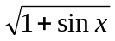 = 0 by iteration method.

NEWTON-RAPHSON METHOD:
Given an approximate value of a root of an equation, a better and closer approximation to the root can be found by using an iterative process called Newton-Raphson method.
Let 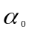be an approximate value of a root of the equation f(x) = 0
Let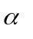be the exact root nearer to 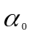
Then =+h where h is very small, positive or negative.
Therefore f() = f(+h) = 0 since is the exact root of f(x) = 0
By Taylor’s expansion,
f() = f(+h) = f()+hf’()+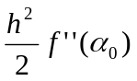+………. = 0
If h is small, neglecting h²,h³,…. etc, we get
f()+hf’() ≈ 0
h ≈ 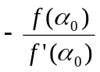 if f’() ≠ 0

=+h = approximately
Let this value be 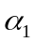
=
is a better approximate root than
Continuing like this, we iterate this process until 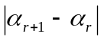 is less than the quantity desired.

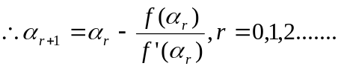

This is an iterative formula of Newton-Raphson method.

PROBLEMS:

- Find the positive root of f(x) = 2x³-3x-6 = 0 by Newton’s method correct to 5 decimal places.

Sol:

Let f(x) = 2x³-3x-6
f’(x) = 6x²-3
f(1) = 2-3-6 = -7 = -ve
f(2) = 16-6-6 = 4 = +ve
a root lies between 1 and 2

Take = 2
= = 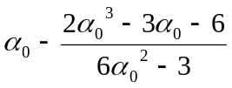= 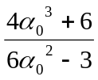

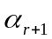 = 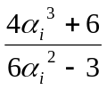

= 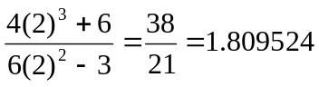

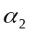 = 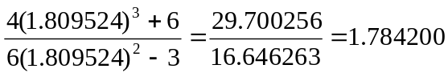

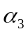 = 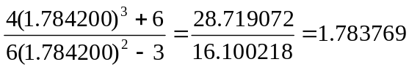

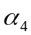 = 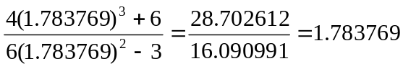

The approximate root value is 1.783769

- Find the positive root of f(x) = 3x-cosx-1 = 0 by Newton’s method correct to 6 decimal places.

Sol:

Let f(x) = 3x-cosx-1
f’(x) = 3+sinx
f(0) = -2 = -ve
f(1) = 3-cos1-1 = 2-cos1 = +ve
a root lies between 0 and 1

Take = 0.5
= = 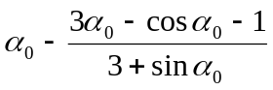= 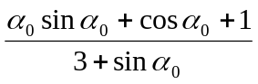

= 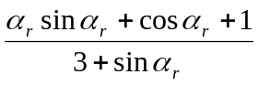

= 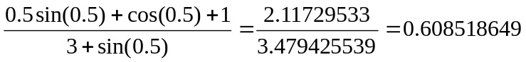

= 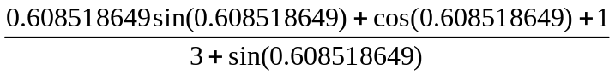

= 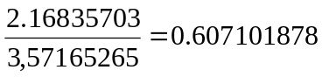

= 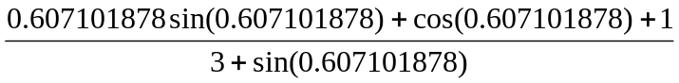

= 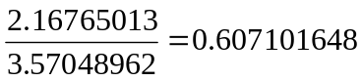

The approximate root value is 0.607102

EXERCISE PROBLEMS

1. Find by Newton’s method, the root of the equation e^{x} = 4x, which is approximately
equal to 2,correct to three decimal places.
2. Find an iterative formula to find 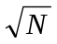 where N is a positive integer using Newton’s
method and hence find 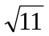
3. Use Newton’s method to find the real root of xlog₁₀x – 1.2 = 0 correct to three decimal
places.
4. Find the positive root of x = cosx using Newton’s method.
5. Find an iterative formula to find the reciprocal of a given number N and hence find
the value of 1 / 19.
6. Find the positive root of cos x = x².
7. Solve for a positive root of x⁴ – x = 10.
8. Find the positive root of x³- x 1 = 0
9. Find a positive root of f (x) = cos x – xe^{x} = 0.
10. Solve for a positive root of x tanx = 1.28.

